Project Management Plan

Tech Services

Luke Schofield (W0435794)

2020

Contents

Steak holder Register 1

Requirements Management Plan 2

Scope Statement 3

Milestone List 3

Schedule baselines 3

Human Resource Plan 3

Project Funding Requirements 3

Change Management Plan 4

Communication Plan 5

Responsibility Assignment Matrix 5

Risk Matrix 5

# Steak holder Register

Additional Information:

-Would have to sanitize device(s)   
-Wash hands  
-Waiver  
-Donations  
-Location  
-Tools  
-Internet access  
-PC setup

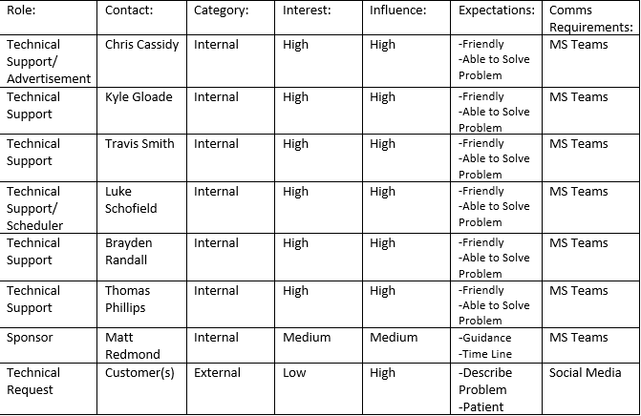

# Requirements Management Plan

Our requirements management plan can be done with this template I provided below, they just need to fill it out and we can work from there generally for this project most of the requirements collection was and will be done through brainstorming with the other project members and the verification was done through a mutual consensus the configuration management would be how the requirements can be changed and the relevant processes to make the change as well as any documentation and mutual approval from the group. Priority would also be filled out based on how important it is and make sure which requirements are at the peak of the hierarchy based on how important they are.

Project Title:

Date:

Requirements Collection:

Categories:

Prioritization:

Configuration Management:

Verification:

# Scope Statement

To achieve this project, we will need to find a location, do advertisements, and collect all the necessary repair and cleaning gear along with make a ticket system to organize ourselves. The goal of this project is to troubleshoot people’s hardware and software problems free of charge to build upon our own troubleshooting skills along with team skills and get real world experience working with customers. To do these things we will need to create support tickets where we listen to them describe the problem we will fill out the ticket in simplified technical terms for the team and then hand it off to be cleaned and then given to a team member to repair and troubleshoot the computer or issue, it will then be cleaned again and handed off back to the customer. Due to Covid-19 we have some major constraints to the project such as the need for social distancing, masks and cleaning things so these will be needed to attend to and where possible we could in fact do some of the repairs remotely such as troubleshooting software issues or if it’s hardware we could have computers dropped off at our houses.

# Milestone List

Tried to keep the milestones concise these are the absolute essentials we needed an advertisement, so people know of it and to find a location and then to run it in person or remotely

* Creating an Advertisement October 14th
* Finding a location for the event October 30th
* Running the event (November-December)

# Schedule baselines

Every week we had a team meeting to discuss what we are working on what we have done and to collaborate on the work at hand to make sure everyone was on task and we where progressing smoothly for the project.

* Assign roles and plan the schedule and outline for the project October 9th
* Creating Advertisements, Tickets & Waivers October 9th-14th
* Determine Resources, Requirements and Procedures needed October 15th
* Find Location for event October 15th-30th
* Setup and Run the project November &December
* Collect feedback and review November 27th-Present

# Human Resource Plan

Human Resources: Chris, Thomas, Luke, Brayden, Travis.

No training will be necessary for this project as we all have the Hardware repair course completed which will make up the bulk of the skills needed for the tech services event. Each person will be flexible in the tasks they are assigned to do acting as they are needed for example if a team members wants help you help them if computers need to be cleaned you clean them this way nobody will be stuck on one specific mundane task like having to clean every single computer that comes through the door.

# Project Funding Requirements

The Cost is going to be almost nothing as we will be using resources that we have on hand to accomplish the project. However, it may be necessary to purchase some fresh cleaning gear to sanitize the machines (due to Covid-19). The estimate being around 68$ for all the extra supplies. Most of these is for in-person at the actual event and most of the group members may have these things the risk being if they do not we may have to invest around 20$ each for the in-person event. We do not need to get funding from external sources and can each provide the required funds.

- Cleaning gear & Wipes (5$)

- Masks / Gloves (15$)

- Anti-Static Straps (15$)

- Paper for tickets (3$)

- Lunch (30$)

# Change Management Plan

If we are not able to secure a work site at NSCC we needed to have a secondary location in place. We decided to use one of the team members houses if this happens or do it remotely.

**Decision Making**

In the event of a decision needing to be made for a minor issue a message can be dropped into the group chat and based on consensus of the replies we can proceed, usually replies are near instantaneous. If the event is a large decision that will have a large effect on the project an email will be sent out with a meeting time where we can assemble on teams to reach a consensus on how to resolve the problem or proceed this is to be done when a simple reply in the messenger will not suffice.

**Documentation / Communication of Change**

If we need to change to our secondary location, we will document this using a change request form, which would contain information like the project name, description of change, reason for change, impact of change and proposed action.

Project Name:

Request#

Requestor:

Description of change:

Reason for change:

Impact of change:

Proposed action:

Priority:

Approval Block:

-

-

-

# Communication Plan

Weekly Meetings on Teams any additional meetings or discussions can be completed on Discord by dropping a message and tagging everyone or sending out an email we can discuss minor issues that arise with chat messages and if we need to all join a call and screenshare a document that can be done as well. Our communication plan is meant to be flexible so we can have everyone in the call at once to reach a mutual consensus but a weekly meeting is mandatory to discuss progress on our project and make adjustments to the documents as needed.

# Responsibility Assignment Matrix

Because of the nature of this project we must work as a team and therefore all team members would be Responsible, Accountable, Consulted and Informed on things that are being done and the processes along with being responsible for helping out with deliverables and making sure the event is successful and all the prerequisites are met according to the schedule.

# Risk Matrix

|  |  |  |  |
| --- | --- | --- | --- |
| Severity  Likelihood | 1 - Low | 2 - Medium | 3 - High |
| 1 - Low | Unable to get pizza ordered to our location and need to obtain lunch another way | Nobody needs computers repaired and we have no tasks. | Unable to find a location for the event |
| 2 - Medium | Unable to fix certain problems customers may have | Cannot get new cleaning gear | No anti-static straps |
| 3 - High | Customers unable to articulate problems that need to be resolved | Get more customers than our team can deal with | Covid-19 Lock down Cancelling our in-person meetings / event locations |